87472743622
830130400046
УМАРОВА Сулушаш Сюндиковна,
Сырбек Каттебеков атындағы жалпы білім беретін мектебінің
ағылшын тілі пәні мұғалімі.
Түркістан облысы, Шардара ауданы

BE GOING TO AFFIRMATIVE AND NEGATIVE

Learning objectives | 5.3.4.1 respond with limited flexibility at sentence level to unexpected comments on an increasing range of general and curricular topics;  5.4.1.1 understand the main points in a limited range of short simple texts or sentences on general and curricular topics;  5.6.1.1 use a structure to be going to express intention and plan on a limited range of familiar general and curricular topics;
Lesson objectives | Learners will be able to:  • Learn and practise be going to affirmative, negative and question forms.  • Use be going to talk about plans and intentions.
Value links | Fairness – If you value fairness, you might be highly sensitive to situations at school or in the workplace where a teacher or a peer has exhibited favoritism or allowed someone to get away with living by a different set of rules to everyone else.
Plan

Stages / Time | Teachers’ actions | Students’ actions | Assessment criteria | Resources
Beginning of the lesson  3 min  14.00-14.03 | - Organization moment  Greeting.  Ask about the weather. | The aim: To develop Ss speaking skills and create friendly atmosphere | At the organization moment T tries to support active Ss.
4 min  14.04-14.08 | - Checking-up the homework.  Revise the vocabulary.  Match the places with the things  Library shows  Museum plays  Art gallery books  Theatre films  Concert hall exhibits  Cinema paintings | Students answer to the teacher’s questions, translate the words and match the places with the things7 | «The praise» method is used to evaluate Ss with phrases like:  “Good job!  Well done!” | Worksheets
Warm-up  6 min  14.09-14.15 | - The theme of our today’s lesson is: to be going to. Before starting let’s remember the usage of the verb to be. Please, students, fill in the gaps with the right form of verb to be (am, is, are)  Group work  I ……. going to see the film.  You ….going to swim.  He ….. going to watch TV.  She ….. going to cook dinner.  It …….. going to rain.  We …….going to play basketball.  They …..going to leave school.  Sam …..going to do homework  Ann …..going to visit her friend.  Tom and Mike …..going to play  computer games. | Students do the task. They complete the sentences with the right forms of the verb to be.  am  are  is  is  is  are  are  is  is  are  Peer assessment: answer key | Formative Assessment  Good job!  Bravo!  Well done!  Excellent!  Not bad! | Power Point Presentation  https://wordwall.net/ru/resource/38157731
Middle of the lesson  Presentation part.  5 min  14.16-14.21 | - Presenting new theme of the lesson by Artificial Intellegence video  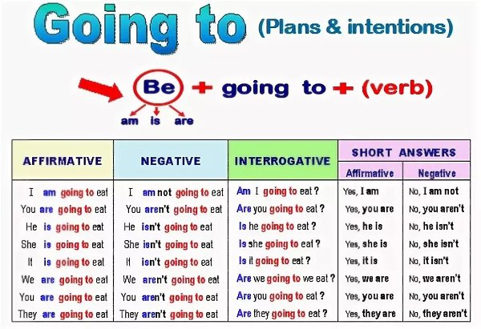  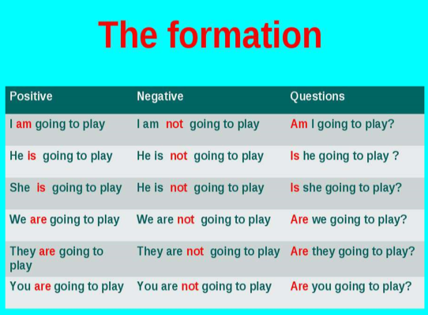  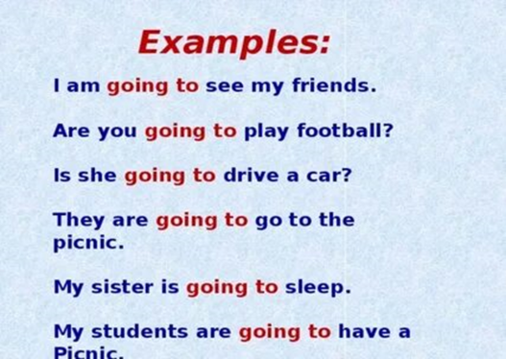 | Students listen and watch to the video very attentively in order to understand the new theme  Students learn the formation of the new grammar material. They understand the Affirmative, Negative and Question forms.  Students read and translate the examples | Formative Assessment    Good job!  Bravo!  Well done!  Excellent!  Not bad! | Power Point Presentation
5 min  14.22-14.27  5 min  14.28-14.33  8 min  14.34-14.42 | - Magic box:  Write the sentences according to the pictures  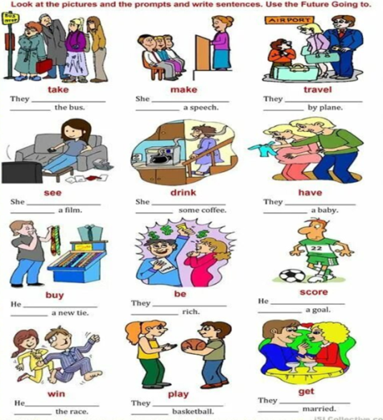  - Speaking task  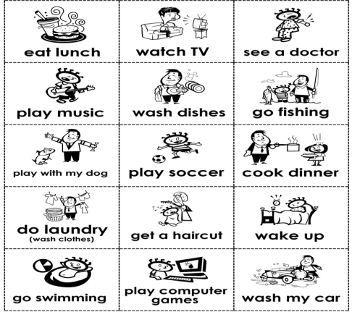  Wordwall activities | Students take out the pictures from the box and completes the sentences with the right variant of the to be going to construction  Speaking task.  - What are you going to do ?  - Are you going to…?  - Yes, I am/ No, I am not.  - I am going to … . | Assessment criteria  - Learn and practise be going to affirmative and negative forms.  Descriptor:  - Students write the sentences correctly  Assessment criteria:  - Students could use be going to while communicating with each other to talk about plans and intentions. |   Cards  Worksheets  Pictures, cards  https://wordwall.net/ru/resource/32211825  https://wordwall.net/ru/resource/13917444
End of the lesson  2 min  14.43-14.45 | Home task:  Ex: 4 P: 101 SB |  | Students use their stickers to show their knowledge according to the lesson.

